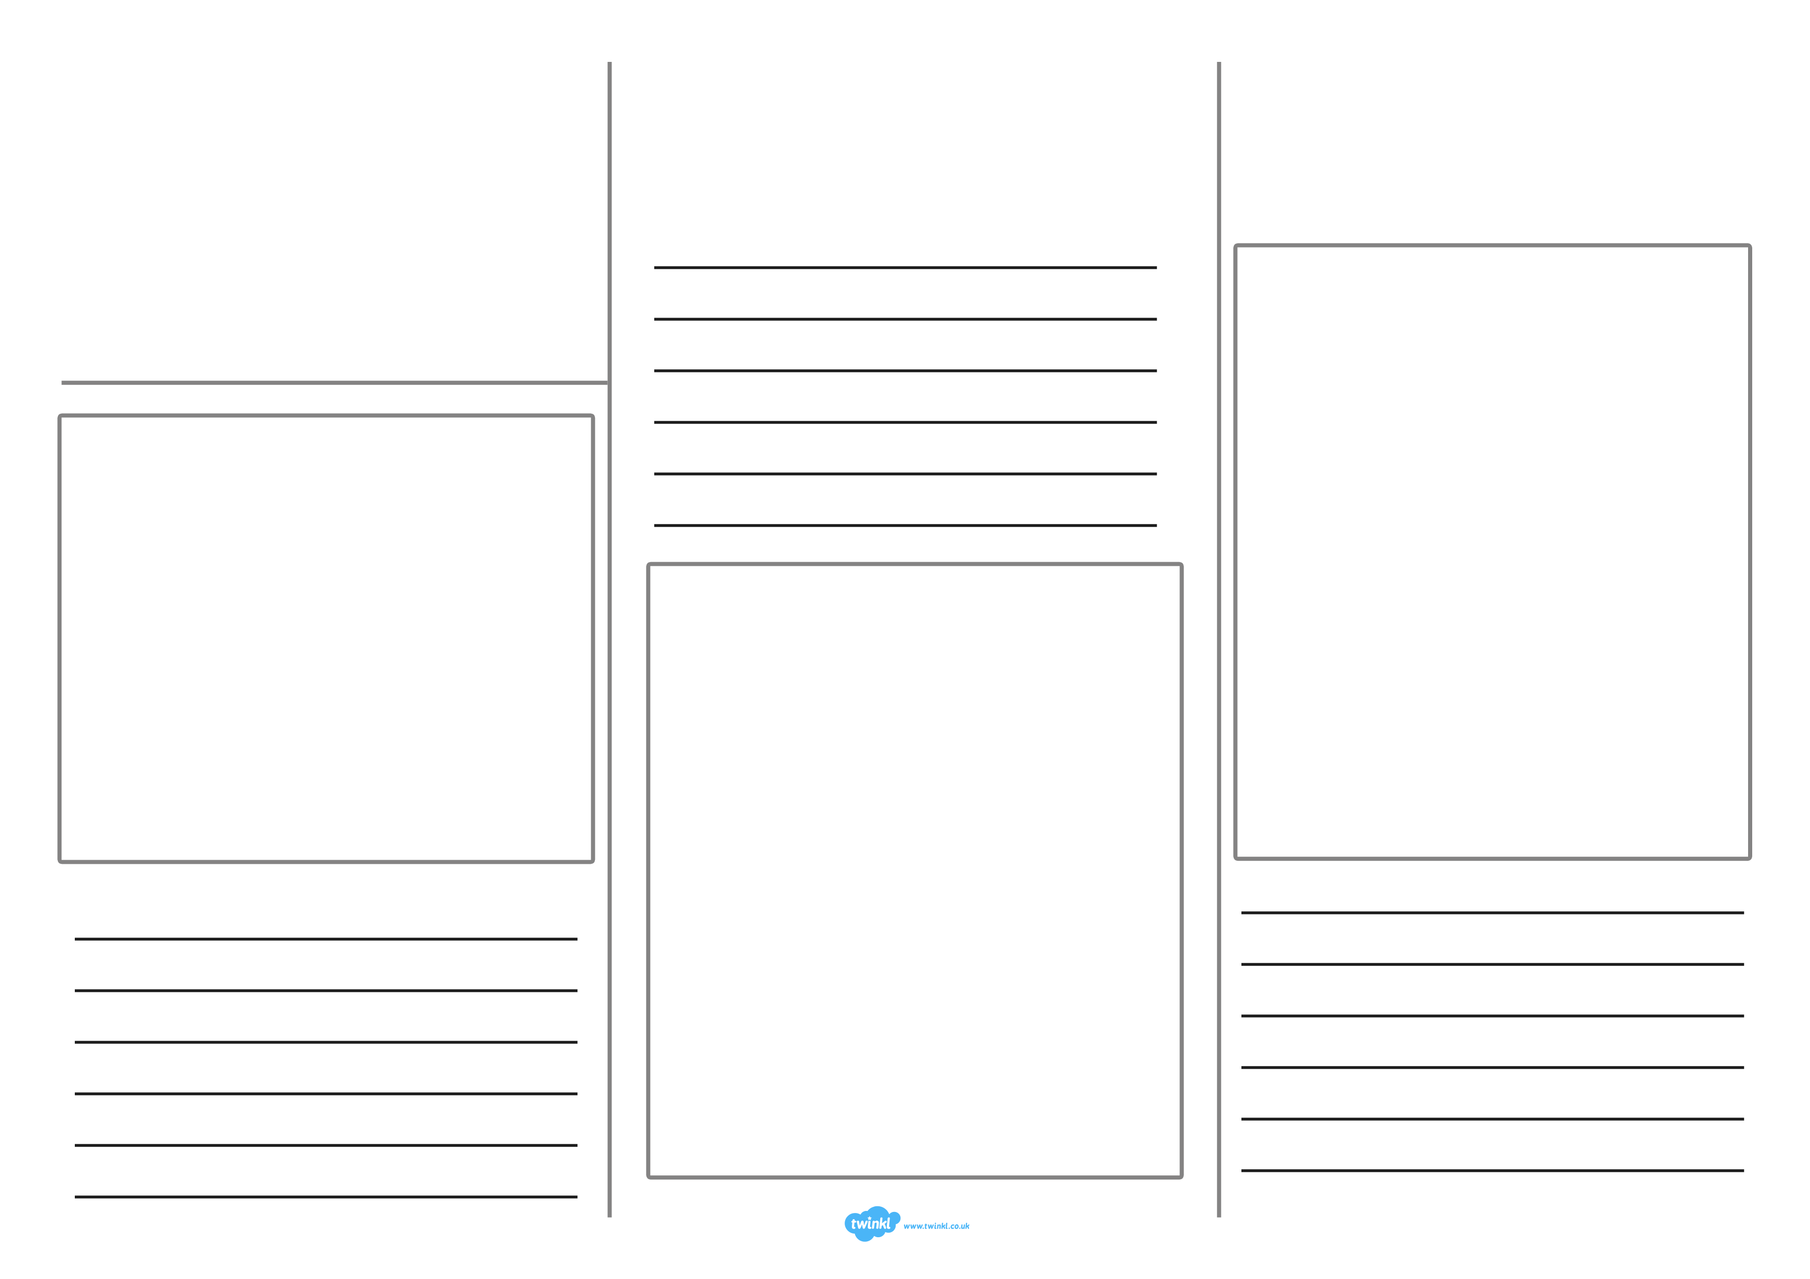
Insert Title
Insert text
Insert image
Insert image
Insert image
Insert text
Insert text
Insert Title
Insert image
Insert image
Insert image
Insert text
Insert text
Insert text
Insert text
Insert text
Insert text

