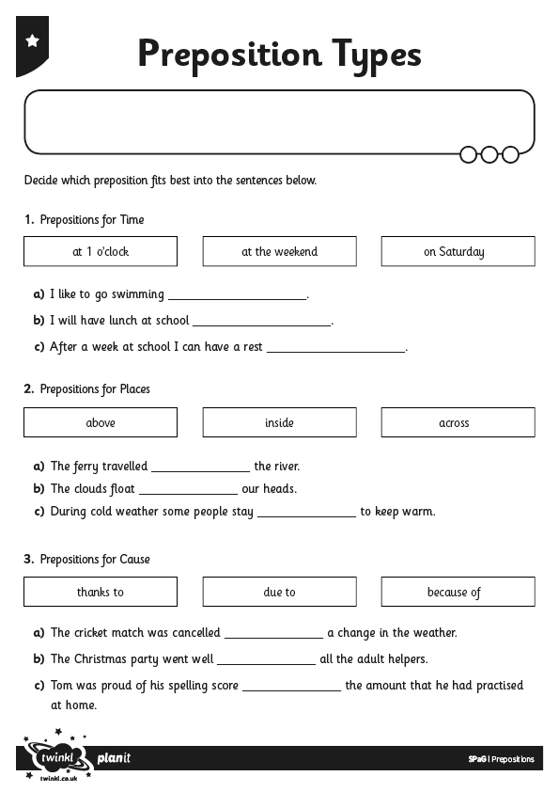
I can use prepositions for time, place and cause.

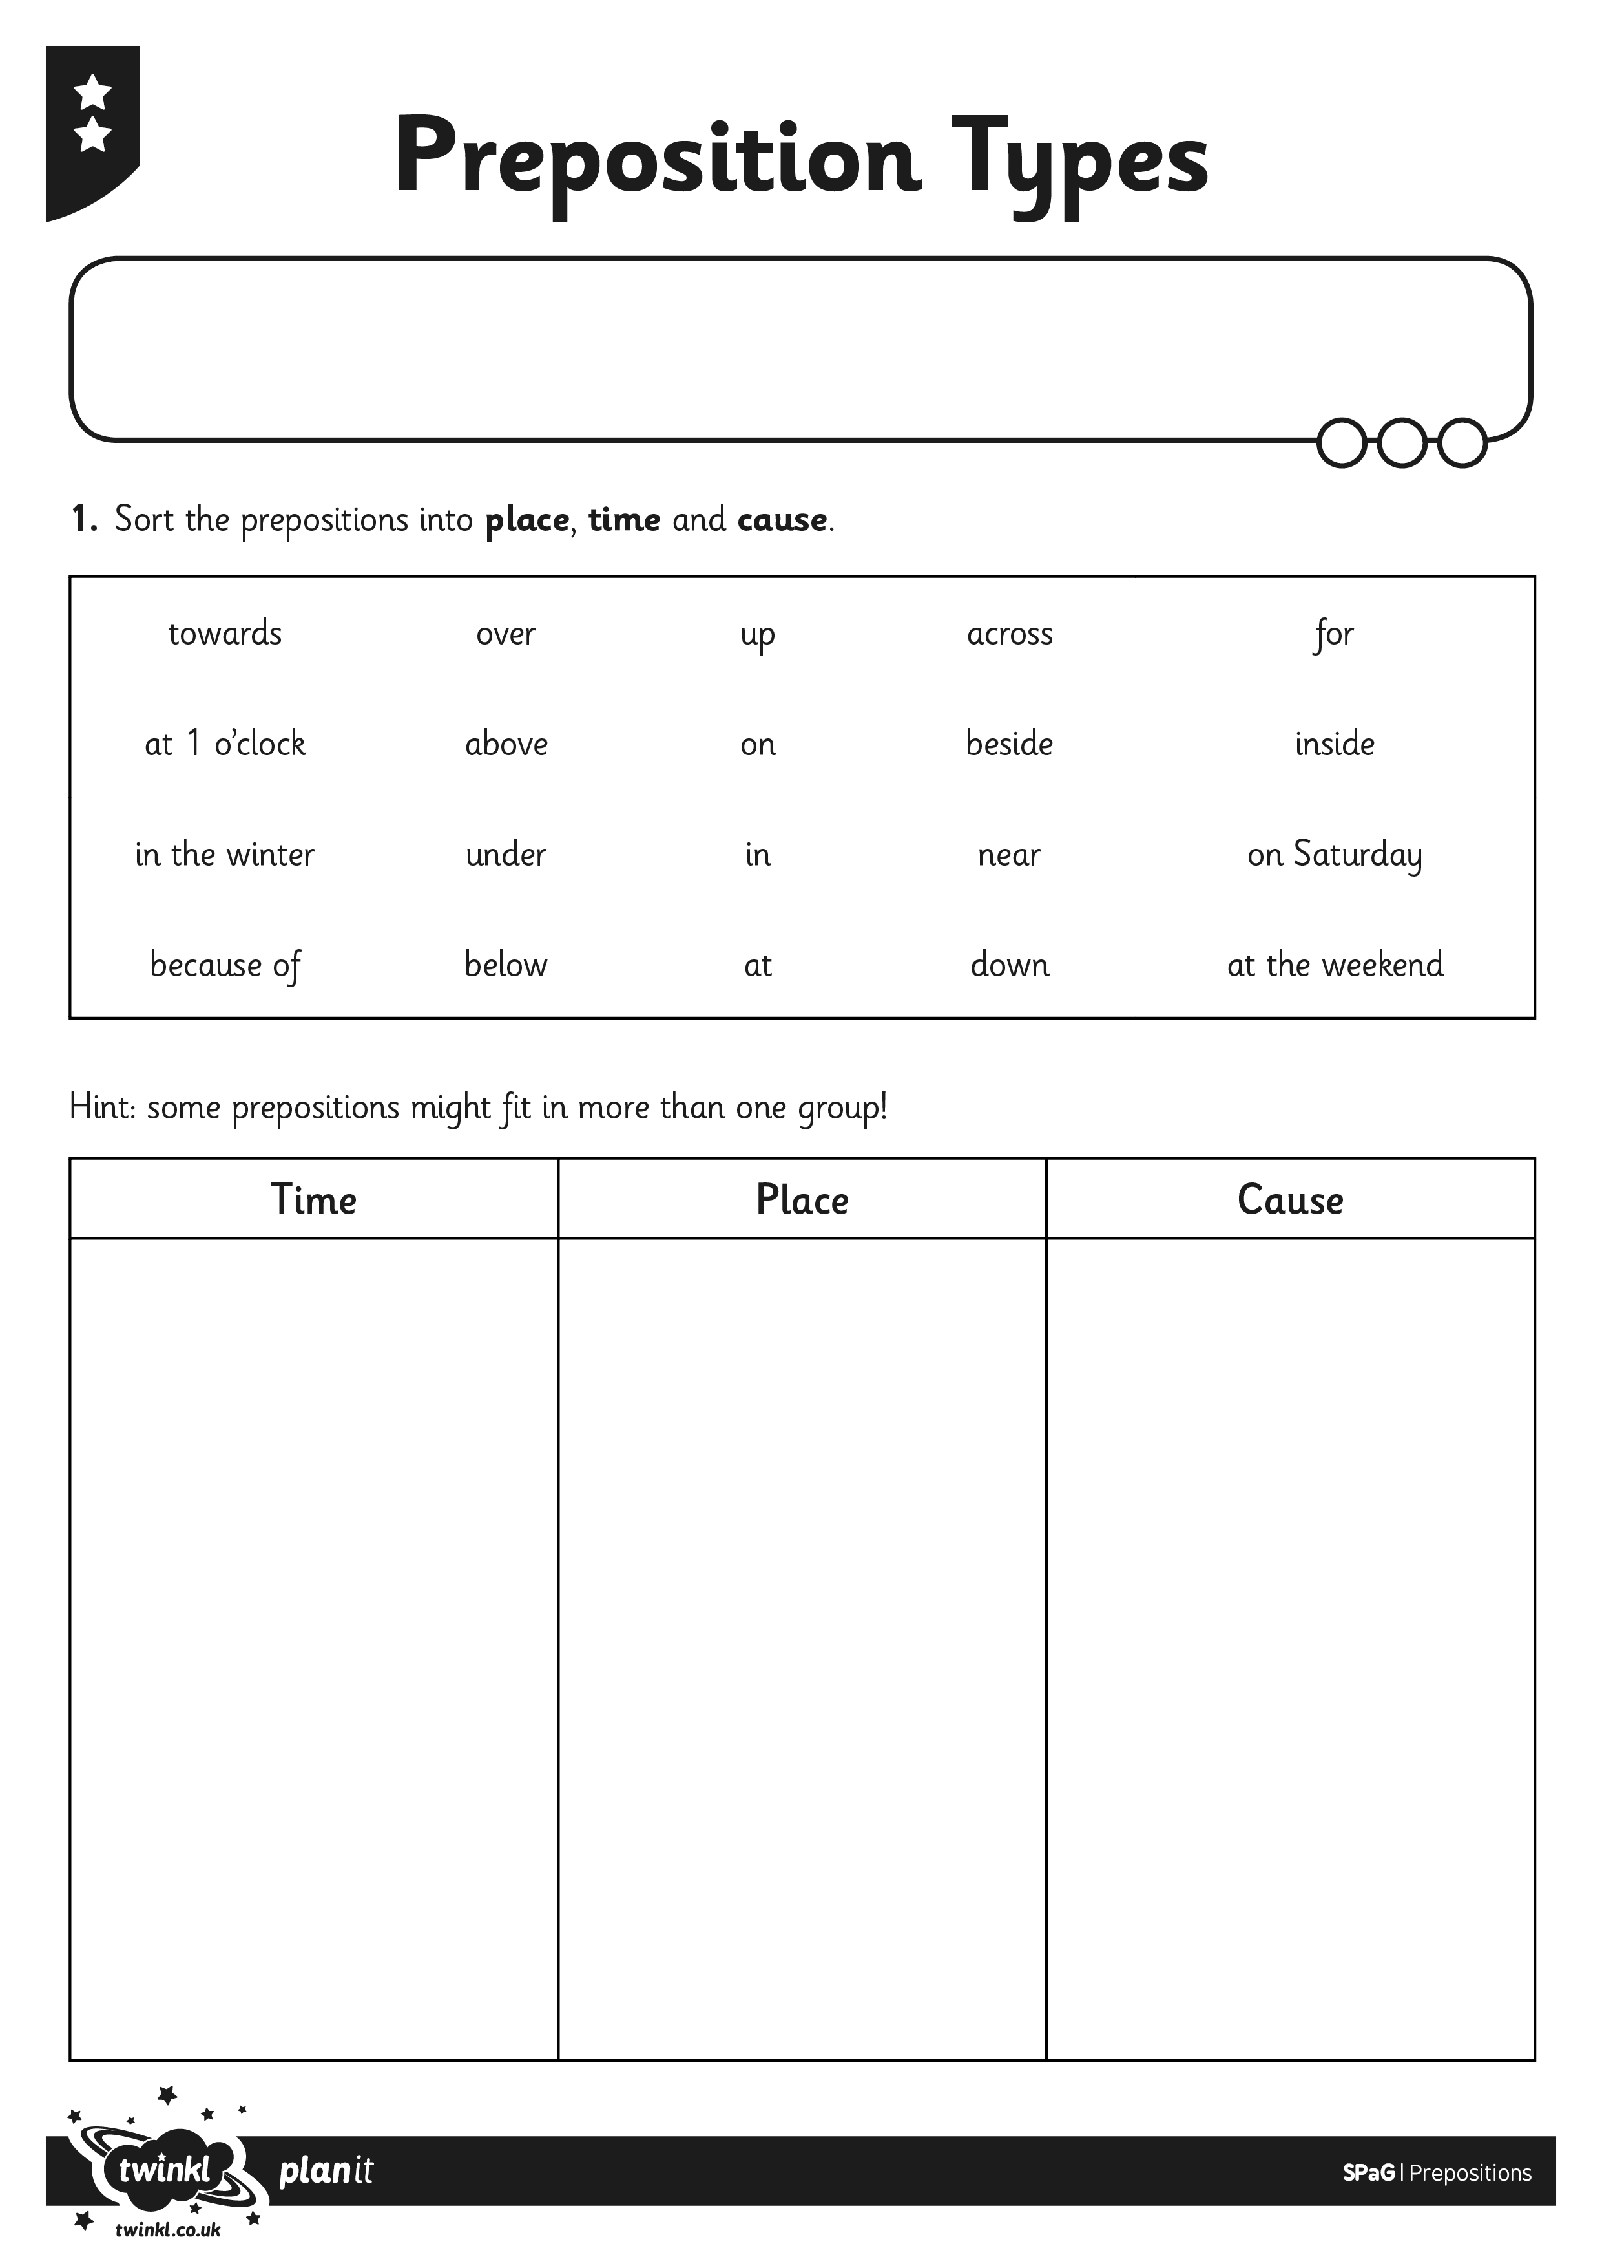
I can use prepositions for time, place and cause.

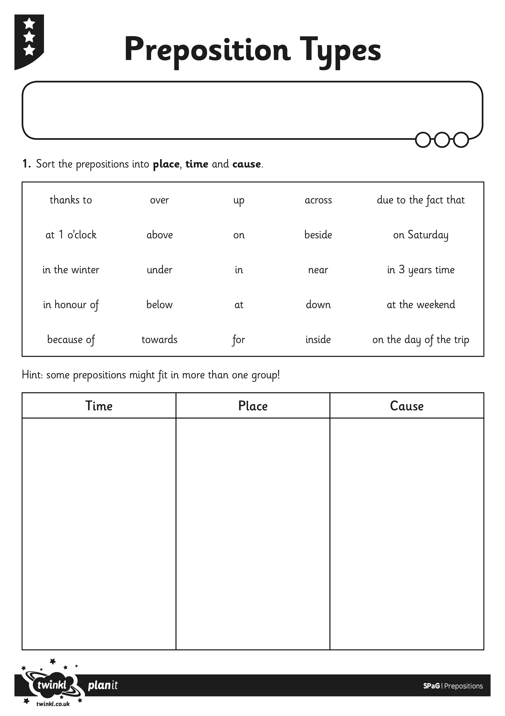
I can use prepositions for time, place and cause.

