Name Date

Look at the two pictures of seaside holidays. Write down as many similarities and differences you can see.

Then Now
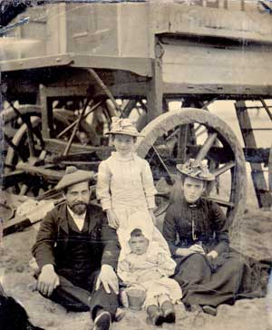

Differences Similarities

Similarities

__________________________________________________________________________________

