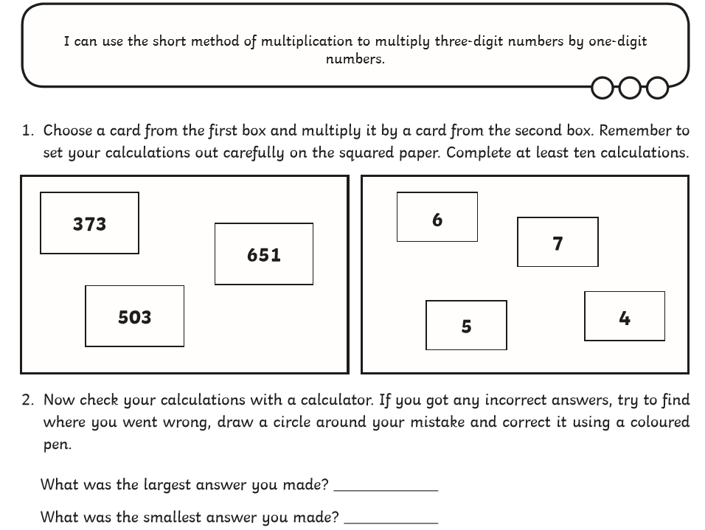
Possible answers:
373 x 6 = 2238 373 x 7 = 2611 373 x 5 = 1865
373 x 4 = 1492 651 x 6 = 3906 651 x 7 = 4557
651 x 5 = 3255 651 x 4 = 2604 503 x 6 = 3018
503 x 7 = 3521 503 x 5 = 2515 503 x 4 = 2012

The largest possible answer was 651 x 7 = 4557
The smallest possible answer was 373 x 4 = 1492

