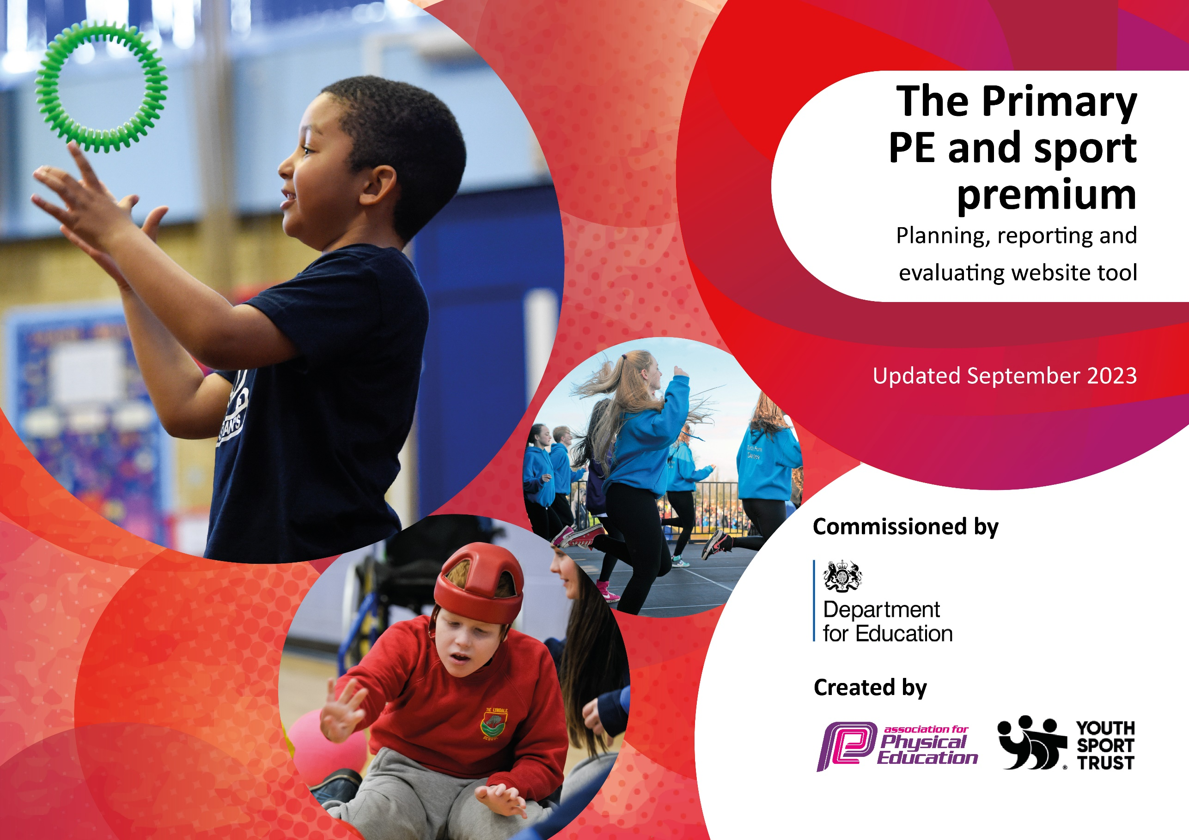

St. Mary’s Catholic Primary School, Billinge
Academic Year 23/24

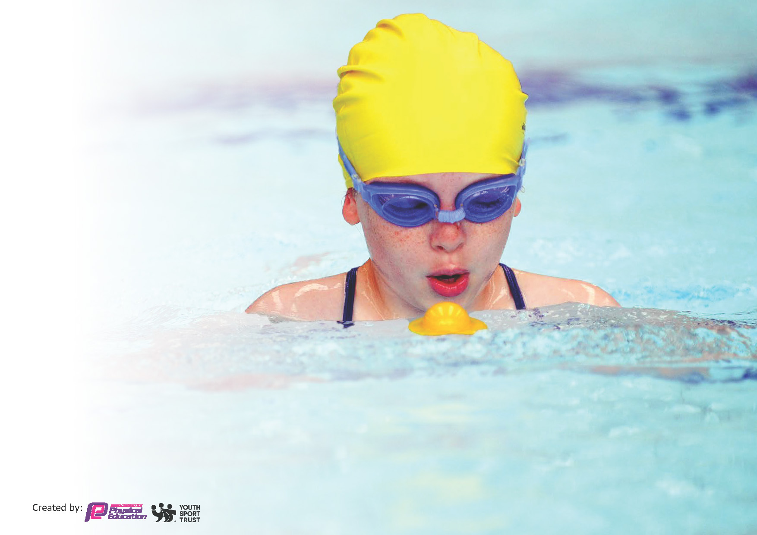
This template can be used for multiple purposes:
by:
- It enables schools to effectively plan their use of the Primary PE and sport premium
- It helps schools to meet the requirements (as set out in guidance) to publish information on their Primary PE and sport premium
- It will be an effective document to support Ofsted inspections enabling schools to evidence progress in Physical Education (PE) and evidence swimming attainment, which forms part of the PE National Curriculum. We would recommend schools consider
the Intent, Implementation and Impact of any spend, as examined within the Education Inspection Framework.

It is important that your grant is used effectively and based on school need.

Schools must use the funding to make additional and sustainable
improvements to the quality of the PE, School Sport and Physical Activity (PESSPA)
they offer. This means that you should use the Primary PE and sport premium to:

- Build capacity and capability within the school to ensure that improvements made now will benefit pupils joining the school in future years
- Develop or add to the PESSPA activities that your school already offers.

The Primary PE and sport premium should not be used to fund capital spend projects; the school’s core budget should fund these. Further detail on capital expenditure can be found in the updated Primary PE and sport premium guidance.

The Primary PE and sport premium guidance, outlines 5 key priorities that funding should be used towards. It is not

necessary that spending has to meet all the key priorities, you should select the priorities that you aim to use any funding towards.

Although completing this template is not a requirement for schools, schools are required to publish details of how they spend this funding. Schools must also outline what the impact this funding has had on pupils’ PE and sport participation and attainment and how any spending will be sustainable in the future. All funding must be spent by 31st July 2024.

The Department for Education has worked closely with the Association for Physical Education (afPE) and the Youth Sport Trust (YST) to develop this template and encourages schools to use it. This template is an effective way of meeting the reporting requirements of the Primary PE and sport premium.
Review of last year’s spend and key achievements (2022/2023)

We recommend you start by reflecting on the impact of current provision and reviewing your previous spend.

Activity/Action | Impact | Comments
- Gold Award achieved with Sainsbury’s School Games in recognition of the school’s continuing commitment to offering the children of St. Mary’s a wide range of sporting opportunities.  - A wide range of sporting extra-curricular clubs continue to be offered throughout the school year from EYFS – Y6.  - Successful Sports Day held with all children participating in a range of events.  - New sports introduced e.g. hula huts, scooter boards, quidditch, glow sports in order to encourage our children to participate in sports other than those seen as traditional sports e.g football, cricket, which are also offered.  - Greater participation at local sporting events for children of all ages and abilities – including those with SEND.  - Teachers/TA skill set and confidence in the teaching of PE has continued to improve as a result of working alongside, and observing, a PE specialist leading/delivering high quality lessons.  - Time has been set aside for the PE subject leader and specialist coach to work together to map out the PE curriculum and to timetable a wide range of extra-curricular clubs.  - Intra school competitions are becoming more fully embedded in our curriculum offer.  - KS2 Afternoon of Fun was run very successfully for the first time – all KS2 children had the opportunity to take part in a range of physical activities e.g sumo warriors, dualling, nerf wars.  - Re development of EYFS outdoor provision to enhance and enable greater levels of physical development e.g. balance bikes, wheeled toys, sand pit, water trays, crates, planks, own garden area, digging/construction tools  - Opening a play park – slide and climbing areas to encourage children, especially ‘non-sporty’ least active children to be physically active during breaks, lunchtimes and after school. (Play Park funded by fundraising – not from Sports Premium) | - Profile of PE continues to rise at school  - More children than ever attending extra-curricular clubs  - Children’s feedback indicates that they enjoy the format of sports day – particularly the working as a team aspect in Part A. In Part B – competitive races, the children do not feel pressurised to take part in the competitive races (as it is voluntary) – older children less embarrassed. Greater participation, from all, as a result. Less excuses as to why some children can’t take part in Sports Day. Lovely atmosphere.  - Numbers attending after school curricular clubs continue to increase. Most clubs on offer are full.  - Gold Award reflects the increasing number of sporting competitions that school is now attending. More children than ever now have the opportunity to take part in out of school tournaments/competitions  - Intra school tournaments mean that all KS2 children have the opportunity to take part in small-sided tournaments in a variety of sports.  - Self esteem of the ‘non sporty’ children and children with SEND has increased. All have a sense of achievement, and pride, at being selected to represent St. Mary’s.  - Children selected for aspire (competitive), inspire (enjoyment) and SEND competitions and tournaments. Confidence of children attending the competitions has increased. Wider variety of children representing the school. Sense of pride amongst all children chosen.  - Greater numbers of children achieving ELG in Physical development  - Play-park is very popular with all children, from EYFS to Y6. All classes have timetabled slots, and the majority of children make full use of the park – leading to more active playtimes | SLT are extremely grateful to the Subject Leader for all of her hard work during 2022/2023.  The profile of PE continues to rise as a result of her work and dedication.  It has been wonderful seeing all of our children having fun whilst being physically active and in seeing more children, of all ages and abilities representing the school at local sporting events/tournaments.
Key Indicators:

- 1. Increased confidence, knowledge, and skills of all staff in teaching PE and Sport

- 2. The engagement of all pupils in regular physical activity – the Chief Medical Officer guidelines recommend that all children and young people aged 5-18 engage in at least 60 minutes of physical activity per day, of which 30 mins should be in school.

- 3. The profile of PESSPA (Physical Education, School Sport and Physical Activity) being raised across the school as a tool for whole school improvement.

- 4. Broader experience of a range of sports and activities offered to all pupils.

- 5. Increased participation in competitive sport.

Key priorities and Planning 2023/2024
Sports Premium Total Allocation - £17, 760 Spent £21,469

Action – what are you planning to do | Who does this action impact? | Key indicator to meet | Impacts and how sustainability will be achieved? | Cost linked to the action
To offer all children daily opportunities to be active and to lead active lifestyles –  Order new play equipment to encourage active playgrounds  Encourage greater use of the Daily Mile track  Use Sports Premium funding to subsidise and offset the cost of sporting clubs on offer.  Train activity leaders to lead games sessions during lunchtimes  A class sports representative to be appointed to the school council (Y2-Y6) to give pupil voice as to how we can improve our sports offer  Maintain trim trails, tyre park to encourage active playtimes – particularly amongst our less active children | All pupils from EYFS to Y6. | - 2. The engagement of all pupils in regular physical activity – the Chief Medical Officer guidelines recommend that all children and young people aged 5-18 engage in at least 60 minutes of physical activity per day, of which 30 mins should be in school. | More children are meeting their daily physical activity goals.  Playgrounds will be more active – less falling out  A wide variety of good quality equipment available for children to use at break times and lunchtimes.  Children’s sports leadership skills will improve as will their confidence and organisational skills  Children will have the opportunity to complete the daily mile  Reduce costs of clubs will mean that numbers of children attending extra-curricular sporting clubs will continue to rise  Pupil voice will become a focus of school council meetings – children will feel valued – their views will have a positive impact upon PE at St. Mary’s. | £ 1800

School to provide transport to local competitions and regional competitions where necessary  School to subscribe to the SHAPES council sports offer.  By subscribing to SHAPES this enables St. Mary’s children to enter a wider variety of sporting events, competitions and tournaments.  To improve teachers’ skills and knowledge in all areas of the PE curriculum by working with an external PE provider who will be able to support staff in the delivery of high- quality PE sessions and CPD.  Purchase Complete PE to support teachers in the delivery of high-quality PE lessons.  To continue to raise the profile of PE within our school and local community through the development of a dedicated website page and through the publication of sporting achievements on the weekly newsletter.  Subject leader time given for subject leader to manage website PE pages  Introduce a 10-week health and well-being programme- Super Beans - with a group of identified children to enable them to discover the importance of physical activity and how it links to their own emotional health and overall wellbeing. | All children who are selected to represent the school  All children who show a desire to represent the school at sporting events  All children  All staff teaching PE  All children  All staff delivering PE  Children  Staff  Wider Community  Targeted group of children | - 3. The profile of PESSPA (Physical Education, School Sport and Physical Activity) being raised across the school as a tool for whole school improvement.  - 4. Broader experience of a range of sports and activities offered to all pupils.  - 5. Increased participation in competitive sport.  - 2. The engagement of all pupils in regular physical activity – the Chief Medical Officer guidelines recommend that all children and young people aged 5-18 engage in at least 60 minutes of physical activity per day, of which 30 mins should be in school.  - 3. The profile of PESSPA (Physical Education, School Sport and Physical Activity) being raised across the school as a tool for whole school improvement.  - 4. Broader experience of a range of sports and activities offered to all pupils.  - 5. Increased participation in competitive sport.  - 1. Increased confidence, knowledge, and skills of all staff in teaching PE and Sport  - 1. Increased confidence, knowledge, and skills of all staff in teaching PE and Sport  - 3. The profile of PESSPA (Physical Education, School Sport and Physical Activity) being raised across the school as a tool for whole school improvement.  - 2. The engagement of all pupils in regular physical activity – the Chief Medical Officer guidelines recommend that all children and young people aged 5-18 engage in at least 60 minutes of physical activity per day, of which 30 mins should be in school. | Our children are no longer prevented from entering competitions due to high cost of transport and lack of school funding. Therefore, more children are able to represent the school at local events, involving a wider range of sporting activities.  Without the Sports Premium funding, school would be unable to pay for transport for the children and therefore the children would be unable to enter/represent the school at local events/tournaments  More children than ever having the opportunity to represent the school at  Aspire  Inspire  Celebrate  Competitions  School Games Gold Mark award achieved  The quality of the teaching of PE will improve  Teachers will feel more confident in delivering high quality PE lessons that have a positive impact upon the development of the children’s sporting skills.  Children’s skills will improve  Once the Sports Premium Funding ceases, it is hoped that our work with specialist PE coaches will have enabled our staff to continue to deliver high quality PE.  The quality of the teaching of PE will improve  Teachers will feel more confident in delivering high quality PE lessons that have a positive impact upon the development of the children’s sporting skills.  Children’s skills will improve  Once the Sports Premium Funding ceases, it is hoped that Complete PE will remain an effective tool in supporting the delivery of high-quality PE  Children’s sporting successes and achievements will be celebrated amongst the school and wider community through the dedicated website page and weekly newsletter  Children who attend the group will be able develop skills of co-operation, resilience, positive relationships and will understand the important link between positive mental health and physical activity. | £1980  £749  £15,120  Cost includes extra- curricular clubs, CPD and supporting staff to deliver high quality PE lessons  £1450 – 3 year subscription  £370

Key achievements 2023-2024
This template will be completed at the end of the academic year and will showcase the key achievements schools have made with their Primary PE and sport premium spending.

Activity/Action | Impact | Comments
- School Games Gold Award achieved  - Super Beans Health and Wellbeing Group successfully completed by all targeted children. Feedback from the children, and their parents, was very positive  - A wide variety of sporting clubs offered throughout the year  - More competitive events attended  - More children, than ever represented the school at sporting events  - Complete PE purchased and used successfully by all staff.  - CPD and staff support sessions delivered throughout the year.  - Successful Sports Day held with all children participating in a range of events.  - KS2 Afternoon of Fun was a successful and enjoyable event  - Dedicated PE tab now up and running on school website to celebrate the sporting life of the school  - Weekly newsletter celebrates sporting achievements  - Sports Representatives selected from Y2-Y6. All have contributed to school council meetings. KS2 Reps have also helped to set up Sports Day, to be supportive partners within KS1/EYFS Sports Day  - Our playgrounds are active places at lunchtime and break times | - PE has a high profile within school  - Staff feel supported in the delivery of PE lessons.  - Staff confidence continues to grow.  - Complete PE has led to further improvements in the teaching of PE  - All children are now in receipt of high-quality PE lessons  - The wide school community has a better understanding of the role that PE plays within St. Mary’s.  - Children’s self esteem has increased due to successes celebrated  - More children have attended extra-curricular clubs  - Extra-curricular clubs offering a wider variety of sports – both traditional and non-traditional | - During the school’s recent OFSTED inspection – via Parent View –  ‘78% of parents strongly agree and 21% of parents agree that their child can take part in clubs and activities at St. Mary’s’

Swimming Data
Meeting National Curriculum requirements for swimming and water safety.
Priority should always be given to ensuring that pupils can perform safe self-rescue even if they do not fully meet the first two requirements of the National Curriculum programme of study

Question | Stats: | Further context  Relative to local challenges
What percentage of your current Year 6 cohort can swim competently, confidently and proficiently over a distance of at least 25 metres? | 80%
What percentage of your current Year 6 cohort can use a range of strokes effectively [for example, front crawl, backstroke, and breaststroke]? | 80%

What percentage of your current Year 6 cohort are able to perform safe self-rescue in different water-based situations? | 80% | Use this text box to give further context behind the percentage.
If your schools swimming data is below national expectation, you can choose to use the Primary PE and sport premium to provide additional top-up sessions for those pupils that did not meet National Curriculum  requirements after the completion of core lessons. Have you done this? | No | It is difficult to provide additional top up sessions due to lack of facilities on offer within St. Helens. Pool time has been allocated across all schools.  No excess funding available.
Have you provided CPD to improve the knowledge and confidence of staff to be able to teach swimming and water safety? | Yes | All staff who deliver swimming must attend swimming training by the LA in order to teach swimming within the LAs pools.

Signed off by:

Head Teacher: | Andrea Hymers
Subject Leader or the individual responsible for the Primary PE and sport premium: | Hayley Cotterill  PE Subject Lead
Governor: | Wayne Leatherbarrow – Chair of Governors  Dave Cairns – PE Link Governor
Date: | July 2024

