Hello to all Year 6 pupils who will be joining us at St. Peter’s in September 2020.

My name is Mrs Pilkington and I am an English teacher and KS3 Co-ordinator at St Peter’s Catholic High School. Our English department is made up of eight specialist English teachers. Our team is led by Mr McGuire. Miss Donnelly is KS4 Co-ordinator. The rest of our team consists of Mrs Abbott, Miss Ainscough, Mrs Anglesea, Mrs Keulemans and Mrs Pendleton.

We feel very excited about meeting you all in September and look forward to many interesting and engaging lessons with you in the time ahead. We are very enthusiastic about English and look forward to sharing our love of literature with you and helping you to develop your skills in English Language

When you start high school you will have English lessons three times a week. Most of your lessons will take place in the English areas in our suite of rooms.

Once every two weeks you will have an Accelerated Reading lesson in the LRC. In these lessons, you will be able to read a book of your choice for pleasure and complete online quizzes to assess your knowledge of what you have read.

During your lessons you will be working through novels, extracts from fiction and non-fiction and completing related tasks. You will develop your skills in reading, writing and spoken language. We will provide lots of opportunities for you to work independently, within small groups and pairs to help you make good progress.

Before you join us, we would like you to do some reading to build on the work you have been doing in Year 6.

Your copy of the novel will arrive at your primary school and given to you at the beginning of next week. (Wk.Bg. Monday 6th July 2020)

I hope you enjoy reading it.

There is also a Nought & Crosses task sheet attached for you to complete.

We would like to see you complete as many tasks as possible but, if you are only able to complete 3, we would like these to create a straight line across the grid. This line can be from left to right, down the page or diagonally but must pass through the middle square.

There is a Star Bonus task at the bottom of the sheet.
There are details about this task on the attached PPT. All completed Star Bonus tasks should be sent to me (or Mr Santus) at one of the email addresses below by Friday 21st August 2020.

These pieces will be judged by Mr McGuire, Mr Santus (your Head of Year) and I.

Make sure you label your work with your full name, the name of your primary school and the name of your form teacher at St. Peter’s.
Star Bonus tasks should be emailed to:
pilkingtons969@saintpetershigh.wigan.sch.uk
Or
SANTUSP@saintpetershigh.wigan.sch.uk

There will be a winner from each form and runner up prizes. The winning entries will be made into full size ‘door’ covers

Good luck. I am really looking forward to seeing your imaginative designs and your creativity. All designs submitted will be made into posters and used for display around the English area.

We are looking forward to working with you and hope that you are excited about joining us.

Have a great summer and we will see you in September.
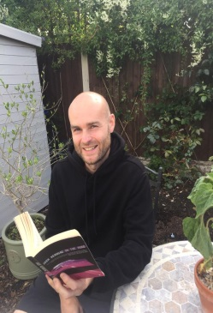

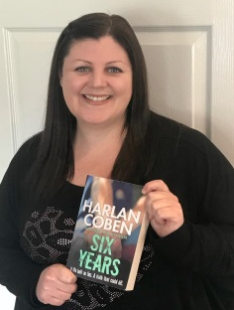
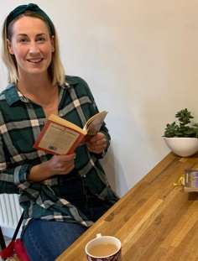
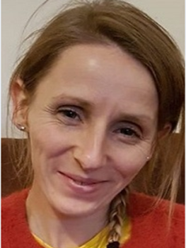
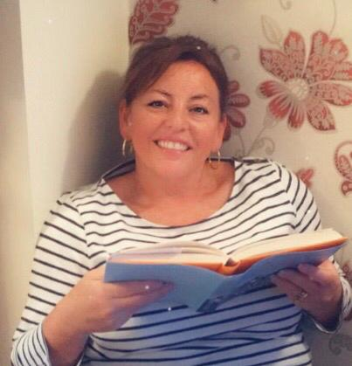
Mrs Abbott Mrs Anglesea Miss Ainscough Mrs Keulemans Mrs Pendleton
Mr McGuire Miss Donnelly Mrs Pilkington

