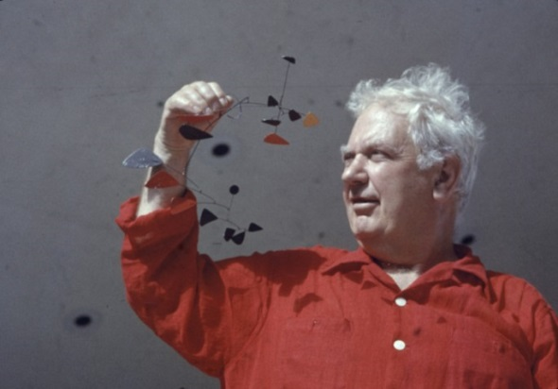

Take a photograph of your finished mobile and send it in to me so that I can share your work with your classmates. Keep them safe and bring them into school when we return so that we can display them for everyone to see. Have fun!

Using everyday materials can you create your own mobile in the style of Alexander Calder?

Think about:

Who is your mobile for? E.g. a baby, a boy, a girl

What parts will you hang from your mobile? E.g. flower shapes, animals, cars, butterflies, shapes, football themed items

What will you make the hanging things from? E.g. cardboard, tin foil, shiny paper, material

What will you use as a frame to hang the items from? Will you use a coat hanger, a piece of wood, a cardboard tube etc.?

How will you hang them from the frame? Will you use wool to dangle them? Will you use thin wire? Will you use strips of cardboard?

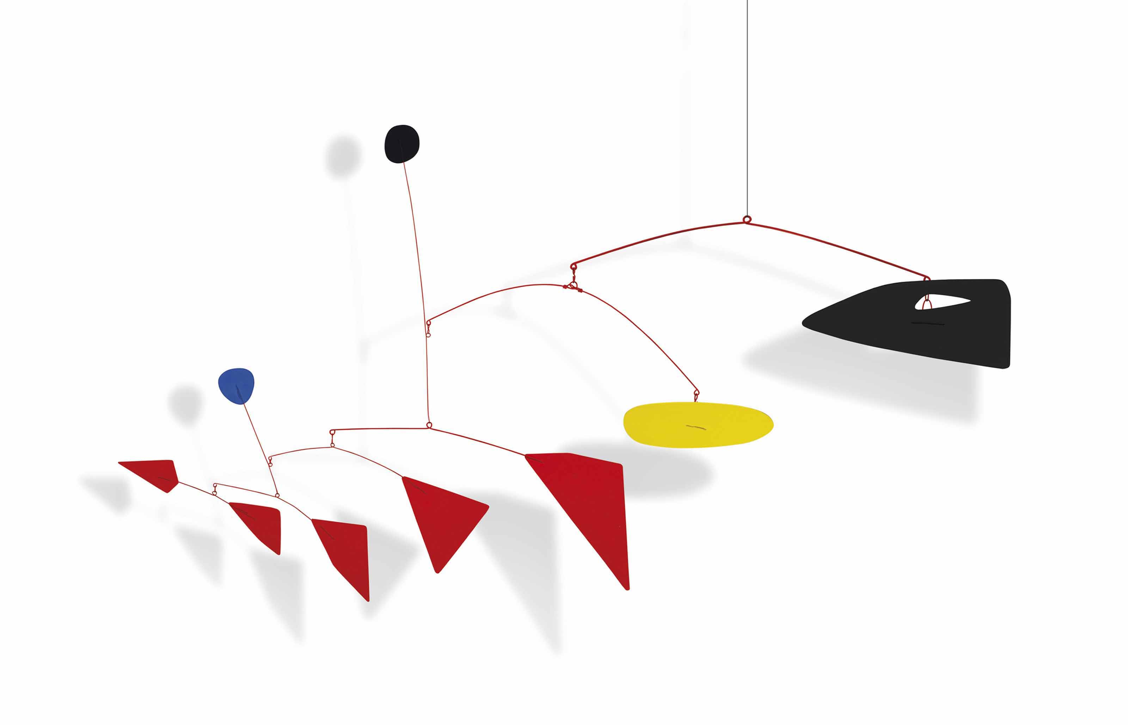

**Alexander Calder**

**Design Challenge**