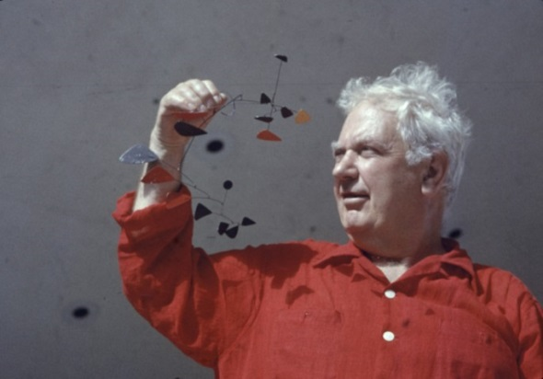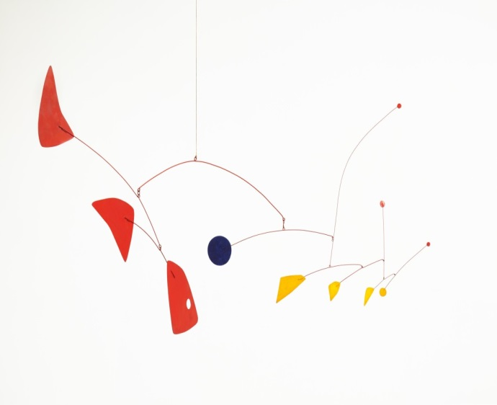

Why I chose this mobile

Interesting Facts:

These websites may help you

<http://artsmarts4kids.blogspot.com/2008/04/alexander-calder.html>

<https://www.sothebys.com/en/articles/21-facts-about-alexander-calder>

<https://kids.britannica.com/kids/article/Alexander-Calder/352899>

A sketch of my favourite Calder Mobile:

Born: 1898

Died:

**Alexander Calder**