STEM WEEK 2020
RAFT BUILDING

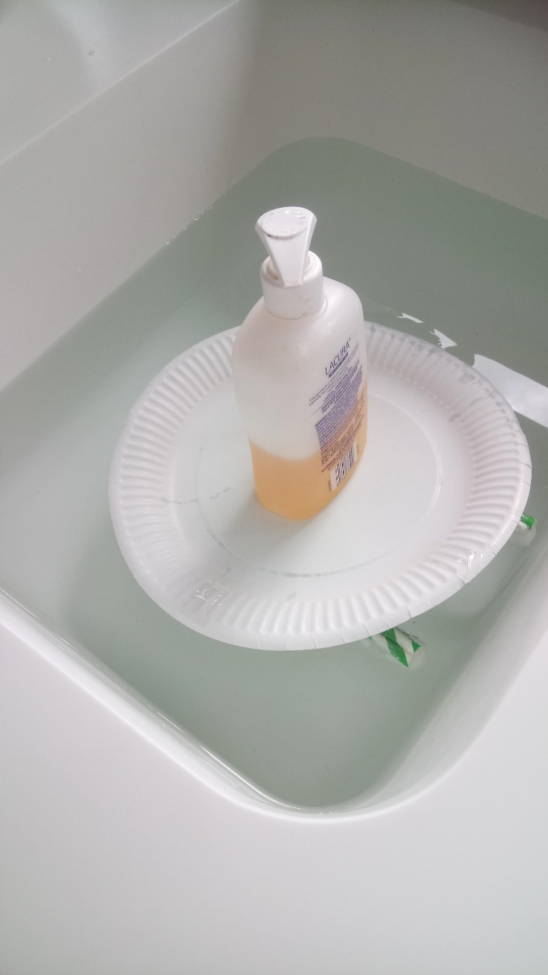
First attempt had small base and small floats underneath. This could only carry light things e.g the soap bottle. Anything heavier caused the float to sink and the top soaked up water. This caused the paper plate to get soggy and bend. It wasn’t strong enough to carry any further weight.

Second attempt at a raft involved using larger floats (milk bottles). This helped the raft cope under more weight because there wasn’t a lot of weight on a single point on the raft. This allowed me to put more and heavier things on top. HARRY POTTER JENGA!
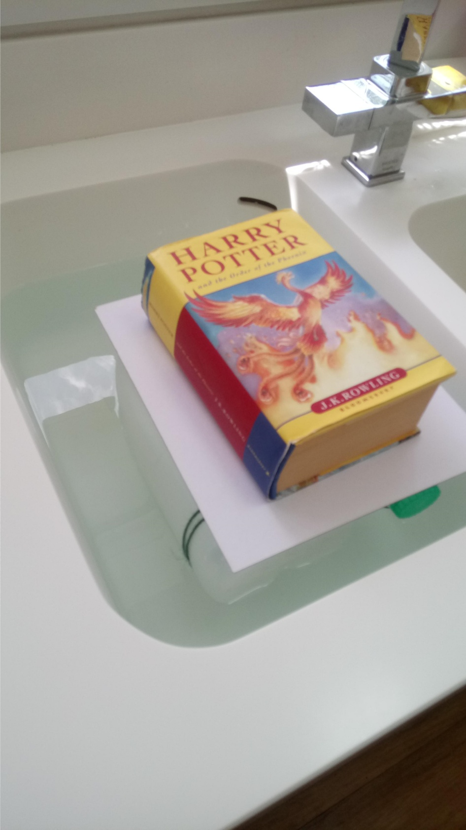
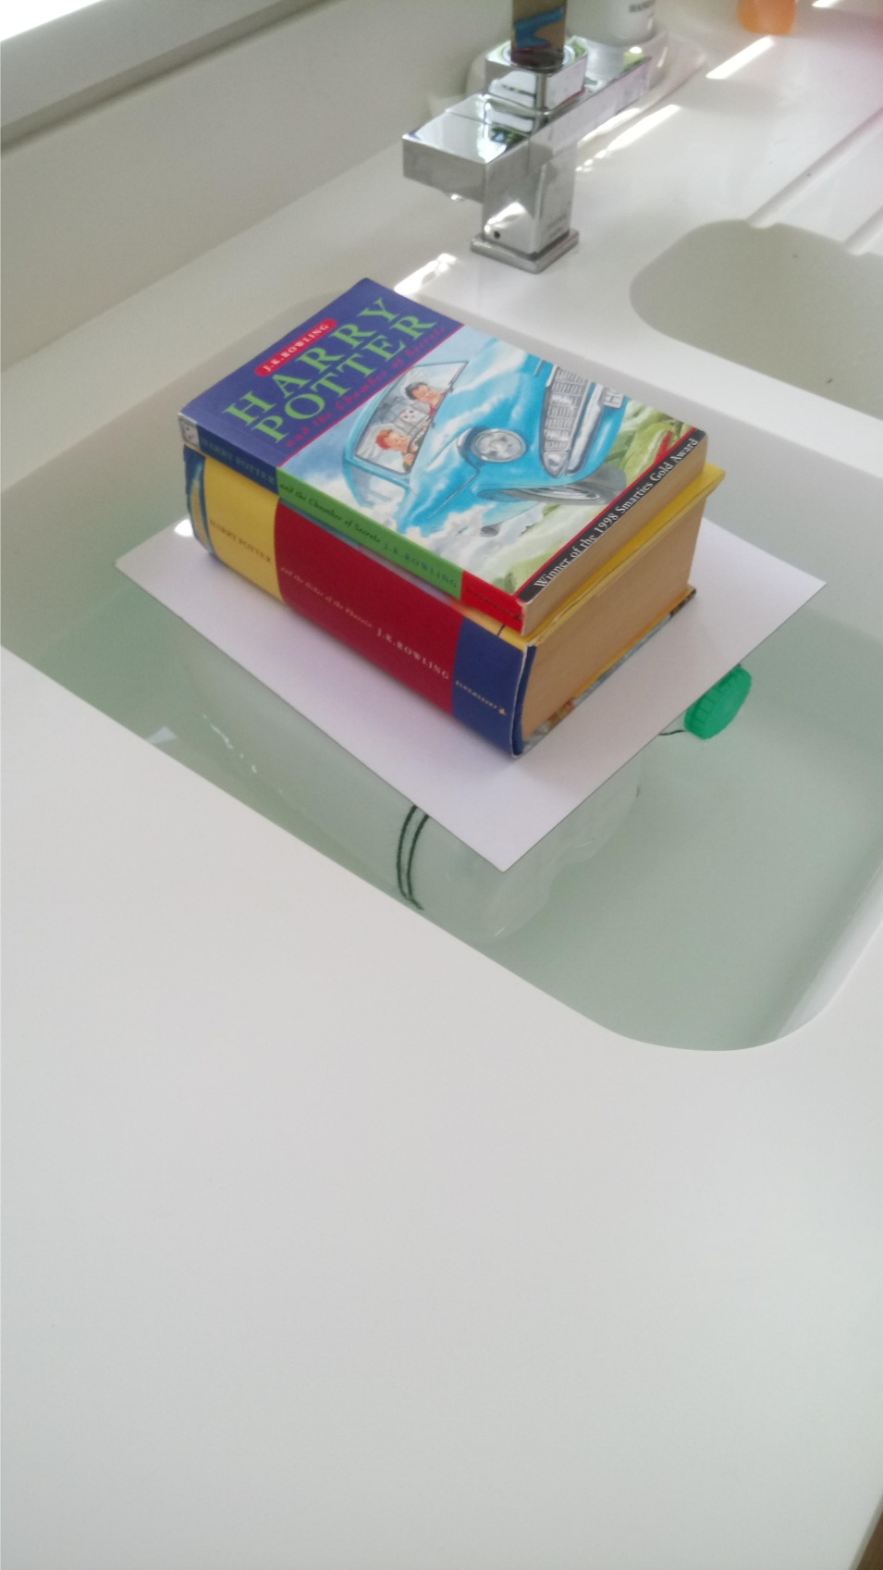
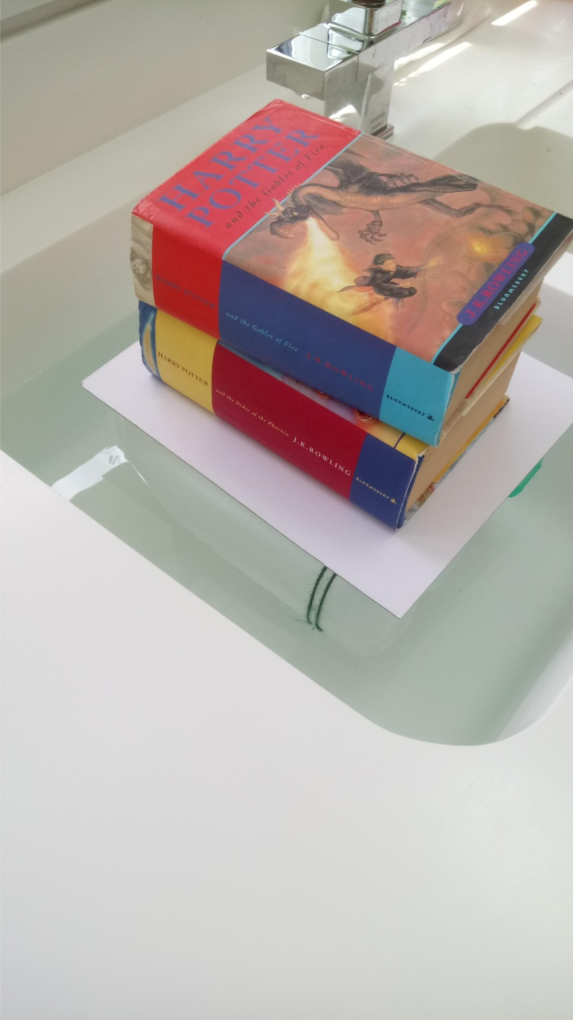
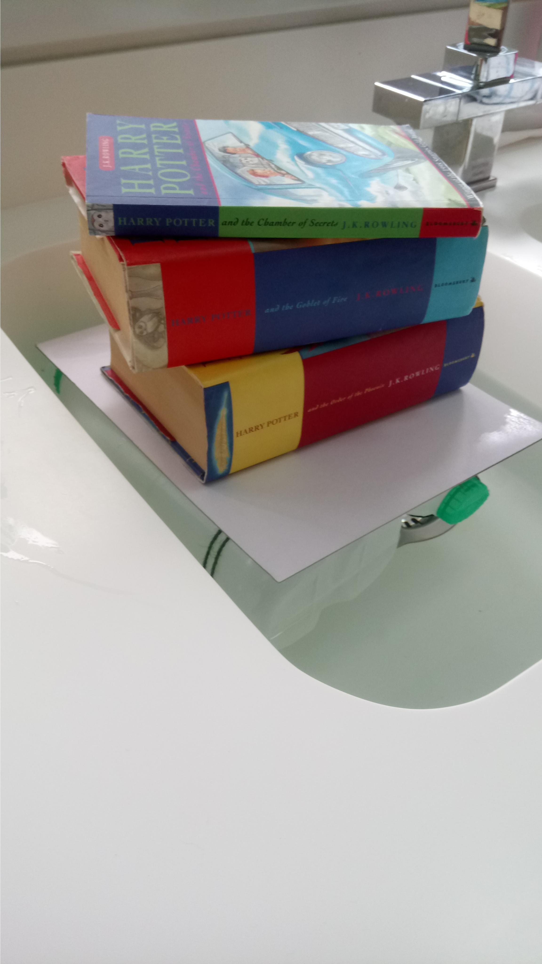

Paper chains
The first attempt resulted in a chain of 213cm. I reviewed the result and found out that to make the chain longer I could reduce the overlap of the paper when making the links to the chains.
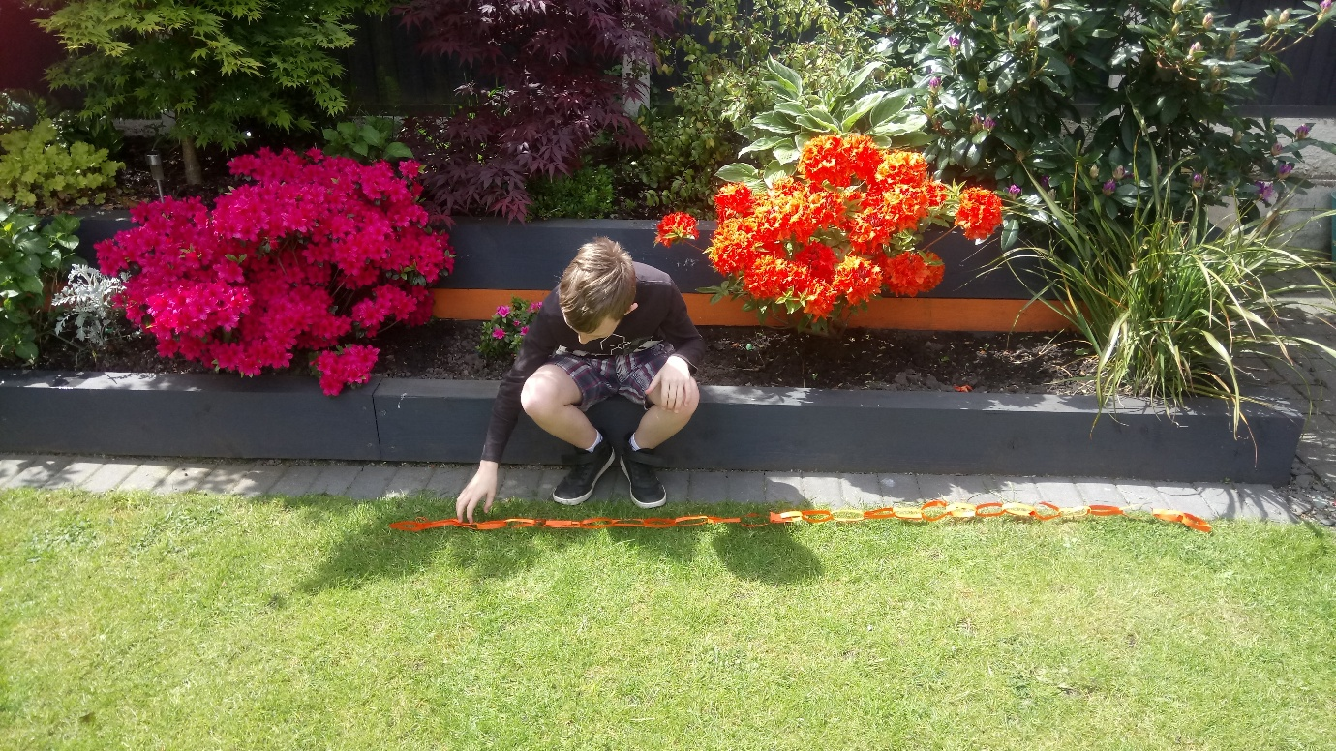

The second attempt at chain making resulted in a length of 276cms.
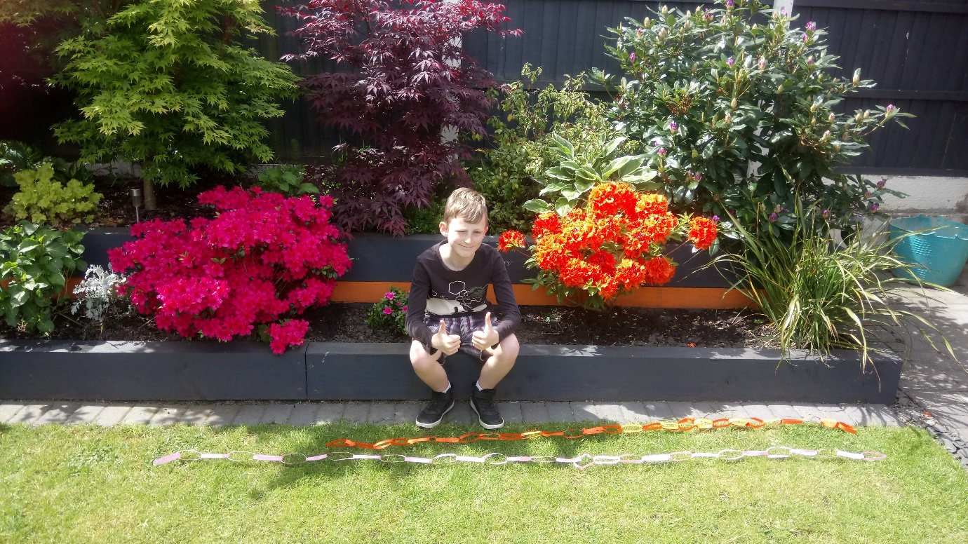

The third attempt, after considering the width of the paper I decided to reduce the width by half . This resulted in a chain length of a whopping 578cm.

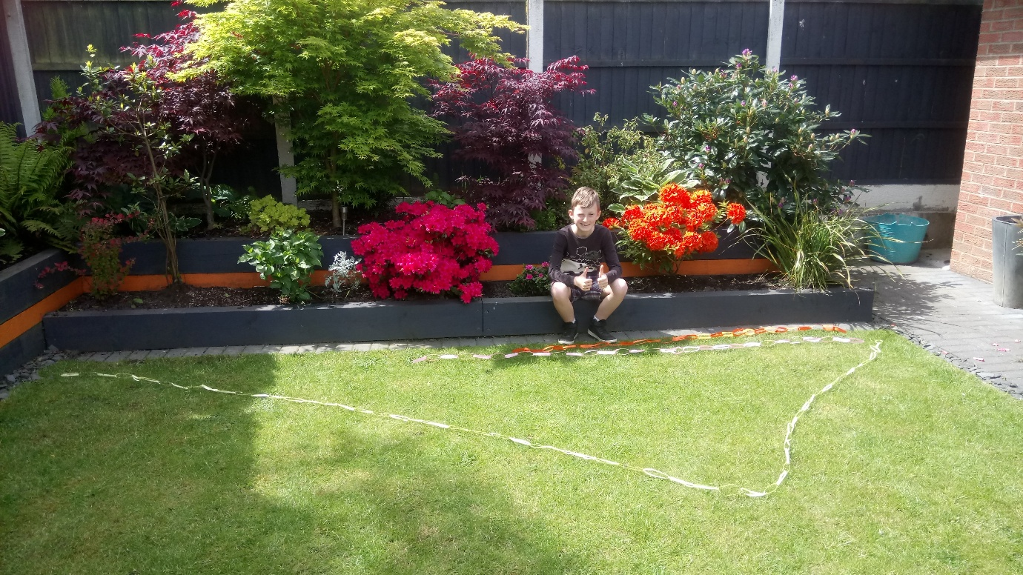

I have thought further and if I did this experiment again I could make the chain even longer by only curling each end as shown.

