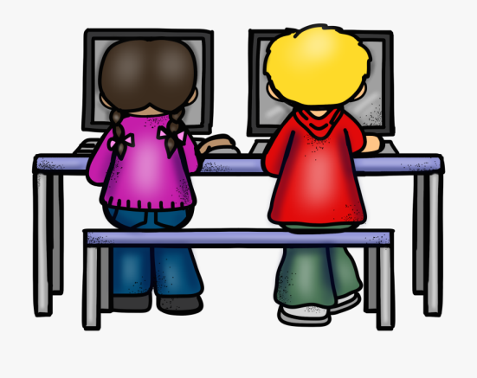
Computing

Curriculum
Statement

Intent
Our Computing Curriculum incorporates the skills and knowledge outlined in the National Curriculum. It has been designed to ensure that our children become digitally literate citizens and can understand and apply the fundamental principles of computer science. Through practical activities, our children will be given opportunities to analyse problems; to debug, create and write computer programs; use algorithms; analyse and represent data and evaluate technology. Alongside developing the children’s computing skills and knowledge, our curriculum focuses upon the importance of working safely whilst in cyber space through targeted E-Safety weeks each term and through regular exploration of safety themes e.g. cyber bullying, safe passwords delivered through our eAware online safety programme.
Implementation
Computing is taught both as part of a topic based/creative curriculum and as standalone lessons. The curriculum is sequenced so that skills and knowledge can be built upon and transferred to other areas of learning and is based around the schemes of work from Purple Mash.
In Key Stage 1 our children will be taught to understand algorithms; to create and debug simple programs; to reason about and predict the behaviour of simple programs; to use technology for a range of purposes e.g. to organise content; to recognise uses of technology beyond the school day and above all else to work safely at all times and to treat technology with respect.
In Key Stage 2 our children will have the opportunity to further develop their computing skills and build upon the skills and knowledge acquired in KS1. The children will be taught to design, write and debug programs; use inputs/outputs, sequences, selection and repetition in programs; detect and correct errors in algorithms and programs; use search technologies effectively – appreciating how results are selected and ranked; use a range of digital devices to design and create programs and to collect, analyse, evaluate and present data using a variety of software and technological devices. Safe working will remain a key feature of the KS2 curriculum and our children will continue to access the themes/elements of the eAware programme through stand-alone lessons/activities. Termly E-Safety weeks will be used to explore acceptable/unacceptable behaviour; reporting concerns; online bullying; safe working; digital footprints and working respectfully and responsibly.
Our children have access to a well-resourced computer suite; class computers, beebots, cameras and a bank of IPads to support their developing computer skills and knowledge.
A ‘fast five’ activity is used to start any computing lesson in order to re-inforce and consolidate knowledge from previous lessons. Teachers refer back to previous learning and share with the children how their learning will be developed and built upon in the next lesson/class so that facts and knowledge can be connected, rather than being taught in isolation. Computing trackers are completed at the end of each topic in order to record which children are working below, at or above expected levels and interventions are delivered when needed.
Work is differentiated to enable children of all abilities and backgrounds to access the computing curriculum.
Impact
Our children will be digitally literate young people who are able to work confidently with technology – becoming active and enthusiastic participants in our digital world. The children will demonstrate a real interest in the technological world and will be able to express themselves and develop their ideas through a range of information and communication technology. The children will possess the skills and knowledge needed for the next stage of their computing education. Above all else, our children will be able to keep themselves safe whilst working in cyber space.

