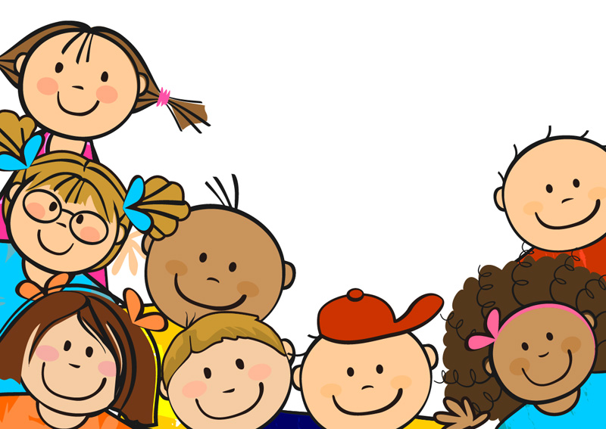

**Treat people how you would like to be treated**

**Respect your own things and things that belong to the school and others**

**Pick things up off the floor – even if they do**

**not belong to you**

**Appreciate others and the things they do for you**

**Follow the rules**

**Be polite**

**Speak nicely to everyone**

**Respect**