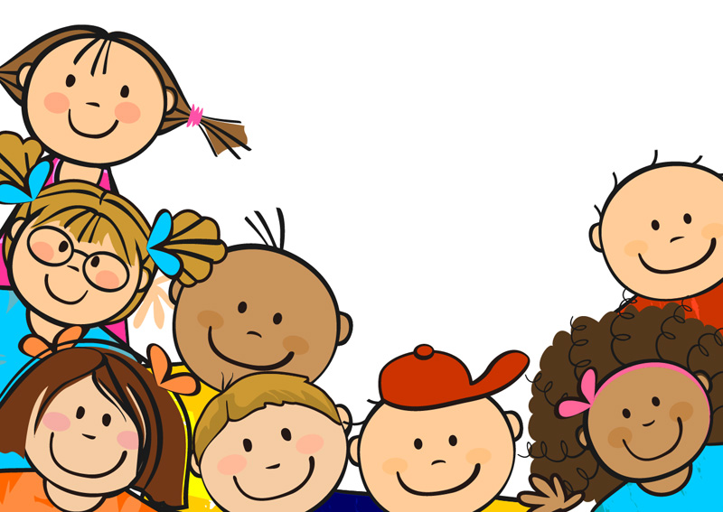

**Listening to and following your conscience**

**Knowing what is right and what is wrong**

**Integrity**

**Telling an adult about someone who is making the wrong choice – even if it is your friend**

**Follow the rules without being asked to**

**Doing the right thing – even when no-one is looking**

**Say sorry**